Digital Interventions INEBRIA (e-INEBRIA) Working Group of INEBRIA SIG
Teleconference
Tuesday 5th June 2018
12.00-13.00 h (CET)
Participants
Name | Institution | e-mail | Skype account | Country | Time difference with CET
Antoni Gual | Hospital Clínic | tgual@clinic.cat | tgualsol | Catalonia | 0h
Hugo López Pelayo | Hospital Clínic | hlopez@clinic.cat | hugolpi | Catalonia | 0h
Robert Tait | Curtis University | robert.tait@curtis.edu.au | rjtait2 | Australia | +7h
Matthijs Blankers | Trimbos Instituut | mblankers@trimbos.nl | matthijs.blankers | The Netherlands | 0h
Leo Pas | Catholic University Leuven | lodewijkpas@gmail.com | leo-pas | Belgium | 0h
Paul Wallace | University College of London | p.wallace@ucl.ac.uk | paul.wallace.100 | UK | - 1h
Anne Berman | Karonlinska Institute | anne.h.berman@ki.se | ahberman | Sweden | 0h
Nicolas Barticevic | Pontificia Universidad Católica de Chile | Nicolas.barticevic@gmail.com |  | Chile | -4h
Heleen Riper | VU University Amsterdam | h.riper@vu.nl |  | The Netherlands | 0h

Minutes
Apologies: Anne Berman, Mathijs Blankers and Robert Tait.
Present:
- Paul Wallace (Chair)
- Toni Gual
- Leo Pas
- Heleen Riper
- Nicolas Barticevic
- Hugo López

- Conference and Preconference INEBRIA Chile 2018: proposal for preconference (NB, HR and LP) and free app (TG, NB)

Preconference: LP has sent a proposal (see paper 1). All agree that it is a good first draft but it should be simpler and more flexible, and we should avoid creating a “second conference” simultaneously. It should give priority to exchange of experiences and to discuss future eINEBRIA SIG priorities. Parallel workshop model (focused on a paper) is a feasible option. Subject to availability of funding support, PW plans to attend and volunteered to facilitate the session /one of the workshops.

Conference: Scientific Committee has reviewed 80% of the proposals. They expect to communicate the results during the following two weeks. HR and Oscar Garcia are working on the plenary. NB did not find a suitable free app. HR thinks that she might get it.

Task 1: LP will reframe the first draft as soon as possible and send us in order to give online feedback in less than a week.

Task 2: NB will review the accepted proposals referred to eHealth and will propose to create specific sessions. Chair might be members of eINEBRIA SIG.

Task3: HR will explore free app for conference.

- Feedback of presentation in WONCA Krakow meeting

LP received very enthusiastic feedback during the meeting, especially from members of EBM Guidelines at Duodecim Medical Publications and members of Nederlands Huisartsen Genootschap. LP offers himself to contact them in order to explore collaborations. We agree that we should wait to finish preconference programm in order to offer a more specific collaboration.

Task 4: LP will contact them with the preconference programm.

- INEBRIA website (HL)
HL has sent a proposal to use website as a work platform for all SIG (see paper 2). We agree with the proposal and highlight that it must be absolutely open. On the other hand, HL will create a twitter account for eINEBRIA SIG and will be activated one week before the INEBRIA meeting.

Task 5: HL will create a twitter account.

- Alcohol app rating procedures

This point was deferred for the next TC because of time constraints.

- Funding proposal (TG)

This point was deferred for the next TC because of time constraints.

Task 6: TG agreed to lead a proposal for funding. After discussion in WG, we will decide which call is the most suitable.

- Plan discussion on key elements for effects of web based support to EIBI (LP and HR)

It was agreed that this would be discussed during the pre-conference workshop and that a paper would be prepared.

Next TC will set up in the last week of July. Please vote the poll as soon as possible: https://doodle.com/poll/t6a572dv5rhpxb4s

Paper 1

Draft for a preconference program for critical debate
Can be freely adapted if less abstracts , if we decide not to request abstracts ,in latter case parallel session mat-y not be needed.
Not yet discussed with Heleen Ripper (please apologize me vfor late sending of my ideas, due to time fixed with Heleen in my agenda on 20/6/18 at 12 AM I did not send out before
Sorry if I am wrong Heleen ?

L Pas 5 6 2018 11 am.
This draft is based on reactions about priorities for our SIG received untill 25/5/2018 on the enquiry among e-inebria SIG members , 20 of which indicated that they consider coming to the preconference names available but cannot be transferred under GDPR rules without contacting first; I will have to send them a mail if they allow.

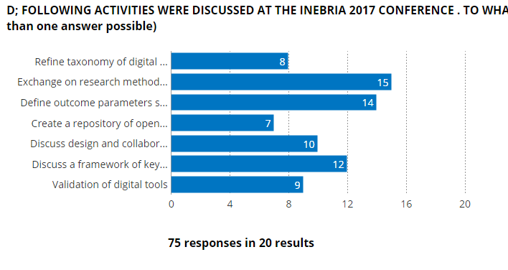
Morning section :
9.15 Introduction to E-INEBRIA SIG MEETNG. A Gual
9.30 – 10.15 Keynote : Heleen Riper. Title to be provided by her

Interactive parallel Workshops or 15 min presentations followed by 15 min debate
- Taxonomy of Digital interventions, where do we stand ? facilitated by representative of A Berman (Bewick?)-
- Key-elements defining efficacy of digital interventions facilitated by L Pas Discussion points to be further developed before conference during summer with ad hoc working group in august online to be proposed to those who replied having interest; I will proceed to a review for our running project in Belgium in june and july; first discussion with H Riper and if possible Matthijs on 20th?
- Parameters for evaluation of efficacy and outcome, facilitated by A Gual or somebody from the other inebria wg on outcome and process measures in collaboration with our group.
12.30-13.30 Poster session can be considered and/or meet the experts corner
Questions can be posted through website eventually to enhance debate

Afternoon section :
13.30-14.30
Call for ideas / projects … 6 selected one slide 5 minutes presentations + 5 min discussion
14.15- 16.45
- Use of different Technological strategies . facilitated by ?
- Digital assessment and brief interventions only or stepped care online facilitated by L Pas
- Targetting different behaviors
16.45- 18.00 Plenary closing debate :
Summary of workshop discussions by rapporteurs
Commentary : What do we know and want to know ? J Cunningham ?
Followed with a debate on Research priorities and next steps in e-Inebria

Paper 2
Role of website in e-INEBRIA Special Interest Group (SIG)
Site: Private Section of INEBRIA website (accessible for all Inebria members)
Categories:
- Section a: Link to relevant papers (to pdf file if open-access)
- Section b: Link to relevant tools (app/website)
- Section c: Link to relevant projects
Protocol:
- Work Group (WG) of eINEBRIA SIG send to Hon Secretary those articles which are considered relevant for each member during the first week of each month. Hon Secretary does every month a search in Pubmed in order to identify relevant papers.
- Spontaneous contribution of non-WG eINEBRIA SIG or INEBRIA members is openly accepted. Once per trimester Hon Secretary will send an e-mail to all INEBRIA SIG members in order to ask their contributions.
- Hon Secretary put together both contributions (regular and spontaneous) in a template (designed and approved by all WG, see in the next page a draft) during the second week of the month. If Hon Secretary hesitates to the suitability or relevance of some contribution, he will ask all WG about their opinion.
- Hon Secretary will send to the website administrator in order to update the website.
* In the future newsletter each two-three months may be considered.

