Meeting of Coordinating Committee
26th September 2018

2:30-5:30 pm
Centro de Extensión, Pontificia Universidad Católica de Chile
AUDITORIO 7B

NOTES

Participants: Jennifer McNeely, Sven Andreasson, Joan Colom, Marcela Tiburcio, Toni Gual, Gallus Bischof, Pablo Norambuena, Lidia Segura, Paul Wallace and Gillian W Shorter.
Excuses: Jean-Bernard Daeppen, Dorothy Newbury-Birch, Amy O’Donnell, Marcin Wojnar and Dag Rekve.

- Opening
SA welcomes everybody to the CC meeting.

- Notes from previous meeting
LS comments that the only issue is that INEBRIA has not yet received the bank transfer from NY. It is agreed that the Secretariat will get in touch with Ann Round from NY to follow this.

- Membership
  - Acceptance of new members
LS comments that the Secretary has checked the 20 candidates and everything seems ok.
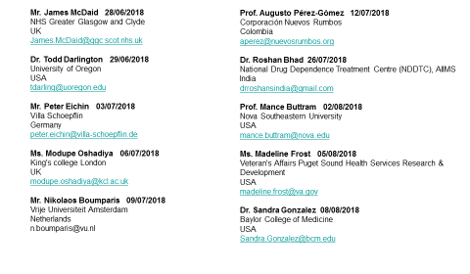 | 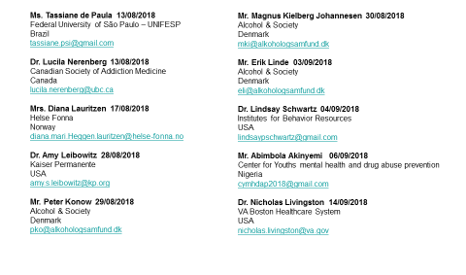

All were accepted.

- Chile conference
PN comments that they are happy with the final developments. He comments that the most difficult was to solve out the payment problems and the administrative payments restrictions (due to the transparency rules) but now everything is sorted out. PN comments that they have finally 5 key speakers, 17 parallel sessions, streaming and translation in two rooms and 180 participants, half from Chile and half from abroad. A social reception and a social dinner is also foreseen.
For the welcome words, there will be representatives from MINSAL, SENDA, WHO, the University and INEBRIA. PN finalizes thanking everybody for the support given.
SA thanks PN and the LOC for the great work done.

- President, secretary and treasurer report
SA comments that the main objectives were achieved. LS summarizes the main activity of the Secretariat emphasising that even though the number of members keeps increasing, the number of active members is still very low. She adds that members were also informed on the new data protection rules and that again 5 scholarships were awarded this year. GB comments briefly the accountability of INEBRIA and that waiting for the income coming from NY, the current figure at the bank is of 5.015,18 €.

- 2019 conference
GB presents the plans for the Conference in 2019 (see slides attached). He comments, among others, that the meeting will take at the Radisson Hotel and that some external Funding is expected from the German Research Foundation (DFG) and the Ministry of Health. It is agreed that a subcommittee should be created as in previous years with teh participation at least from JM, Pablo Norambuena, LS and SA. It is also agreed that efforts should be done to promote the pariticipation of people from Eastern European, Baltic and Scandinavian countries. It is proposed to include as plenary speaker Lana Popova to discuss on the issue of BI among FASD. GB comments that the website will be available before the end of the year. He is very confident that no major problems will occur since the company hired has plenty of experience and they just organized a large conference with more than 400 participants. He is not sure about the conference having some benefits.

- Proposals for meetings
  - 2020 Yearly conference and onwards
SA comments that there has been some preliminary conversations with Aisha Holloway and Dorothy Newbury-Birch on the plans for 2020 conference and that there is a meeting planned for the 19th of November in Edinburgh to discuss further. No agreements have been made yet.

- Elections CC. Nomination committee.
SA comments that only JBD wants to step down from the CC. He adds that members were requested by e-mail to nominate candidates and the nomination committee (NC), conformed by Maristela Monteiro, Niamh Fitzgerald and Jim McCambridge has been asked to help with this process too. Up to now, no candidates were proposed by the NC.

- Feedback from SIG
PW comments on the intense activity of the eSIG during the year. He adds that the core group meets on-line every two months and that they would like to open the scope of the group. He finalizes saying that they are very satisfied on the pre-conference session organized by the eSIG, not only on number of participants but also on the contents covered. They would like to continue promoting Digital perspective in the conferences. He announces that he wants to step down as coordinator of the group.

GWS reports that there has been great progress of the group, that the main objectives of the project and the ORBITAL sig have been achieved, and that the group would like to hear back from INEBRIA members on where to go next and how to improve the final report.

- Journal agreement – terms and management
LS comments that conversations have been stablished with the journal and she proposes the CC to decide on how to deal with the waived-fee submission. No decision is made on this.

- News from WHO
LS comments that DR has not been able to join the CC meeting because he is now working intensively in the launch of the SAFER initiative in NY on Friday and that WHO keeps promoting SBI as one of the main policy actions. LS comments that she believes that WHO needs INEBRIA support on this.

- ICARA report
SA comments that he and Niamh Fitzgerald (the INEBRIA representative to the group) participated in the last meeting. He believes that it is important for INEBRIA to be part of ICARA.

- AOB
Marcela Tiburcio explains about the work on INEBRIA Latina (bulletins, Delphi study, etc). She thanks the support of PAHO in organizing both technically and economically the workshops and sessions during the conference. She announces that there will be a specific separate meeting on INEBRIA Latina.

